- Log into your computer.
**Your Username and Password is the same as the Username Password you use to log into your Portal to see your pay stubs**

- When Launchpad opens double click GoMath icon

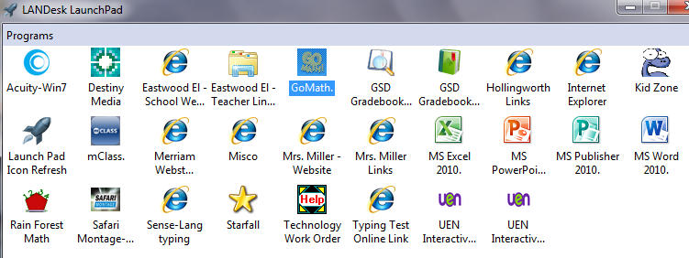

- When this opens be precise on the selections
- Choose Utah then Choose Granite School District, …. Then Taylorsville Elem School…

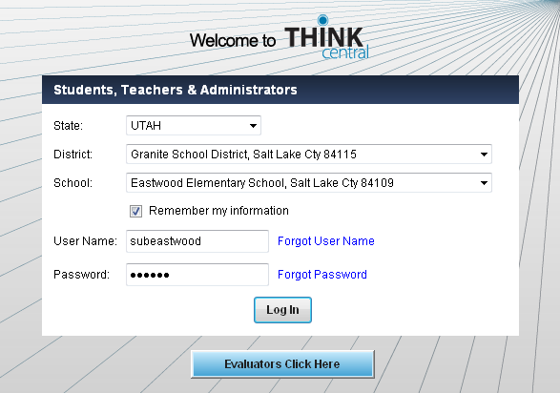

- Type Username subTaylorsville Type Password gomath
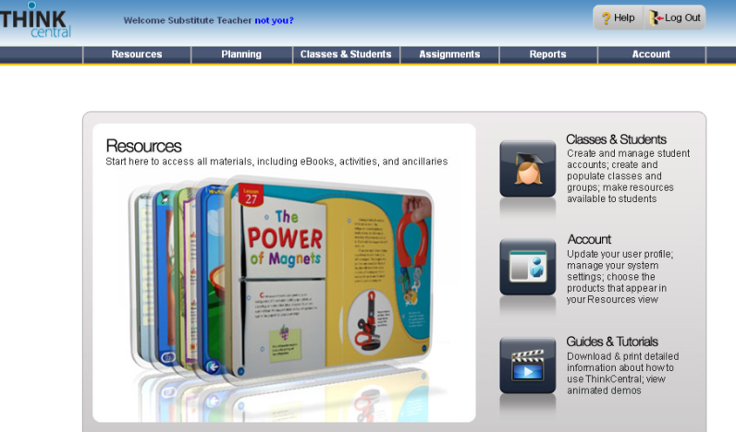
- Click Log In

- Click Resources to go to Teacher/Student Manuals

